We’re Hiring: Join our Team
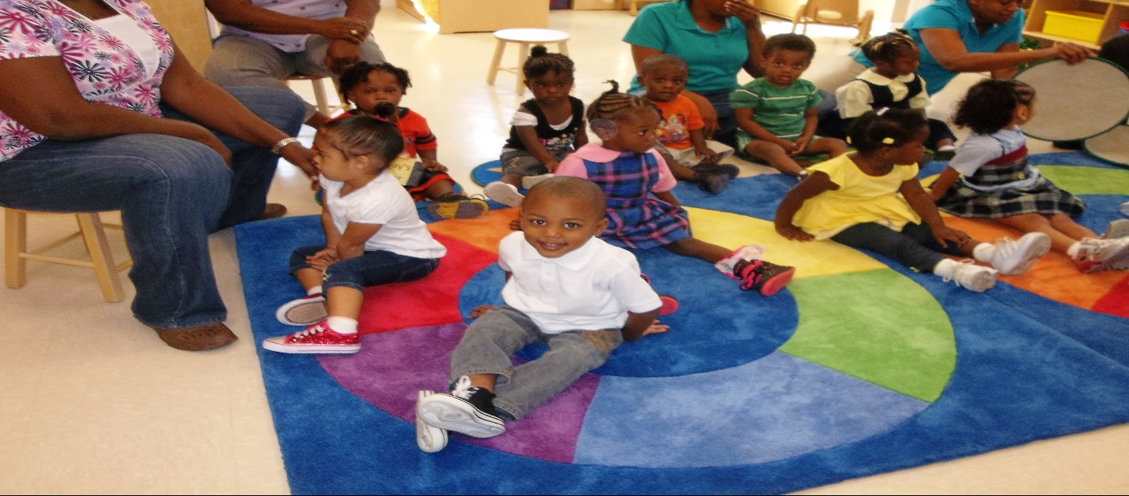
A child’s life is like a piece of paper on which every person leaves a mark.
Early Childhood Education Professionals for Early Head Start Program are needed.
Must possess a minimum of a CDA in Infant/Toddler, 12 credits in Early Childhood or Child Development. Associate’s degree preferred. The starting salary for this position is $31,200. $500 signing bonus paid after 6 months of successful employment.
Our child development centers mission is to provide quality care and education while supporting families in the process of obtaining stable or permanent housing.
See our website @www.cotsdetroit.org for full job description and additional information. Resumes can be emailed directly to shightower@cotsdetroit.org.

